Practice Final Exam
AE 302, High-Speed Aerodynamics,
Closed book.

Problem type 1.

Does the following supersonic flow compress or expand

In streamwise direction what happens to the velocity, pressure and density? Do these flow field properties increase or decrease?

In reality isentropic flows do not exist? What can cause a flow to be non-isentropic. Does the total pressure increase or decrease as a result of non-isentropic effects?

Explain the mechanism of an expansion wave? Why is it isentropic? What is the difference with an expansion shock?

Sketch a shock diamond at the exit of a nozzle. What is a necessary condition at the exit of the nozzle for a shock diamond to form?

Given a incompressible pressure coefficient distribution over an airfoil, sketch the compressible pressure pressure coefficient distribution at Ma=0.4 and Ma=0.7.

What flows can be computed with the linear perturbation potential equations? What flows cannot be computed (accurately) with these equations?

How would you identify a shock wave in a flow computation with Fluent?

Problem 2.
See midterm

Problem 4.

Consider a wedge with a θ=15 degree half angle in a Mach 5 inviscid flow under a zero angle of attack, as sketched in the figure. The base pressure p₁ is equal to the freestream static pressure p∞.
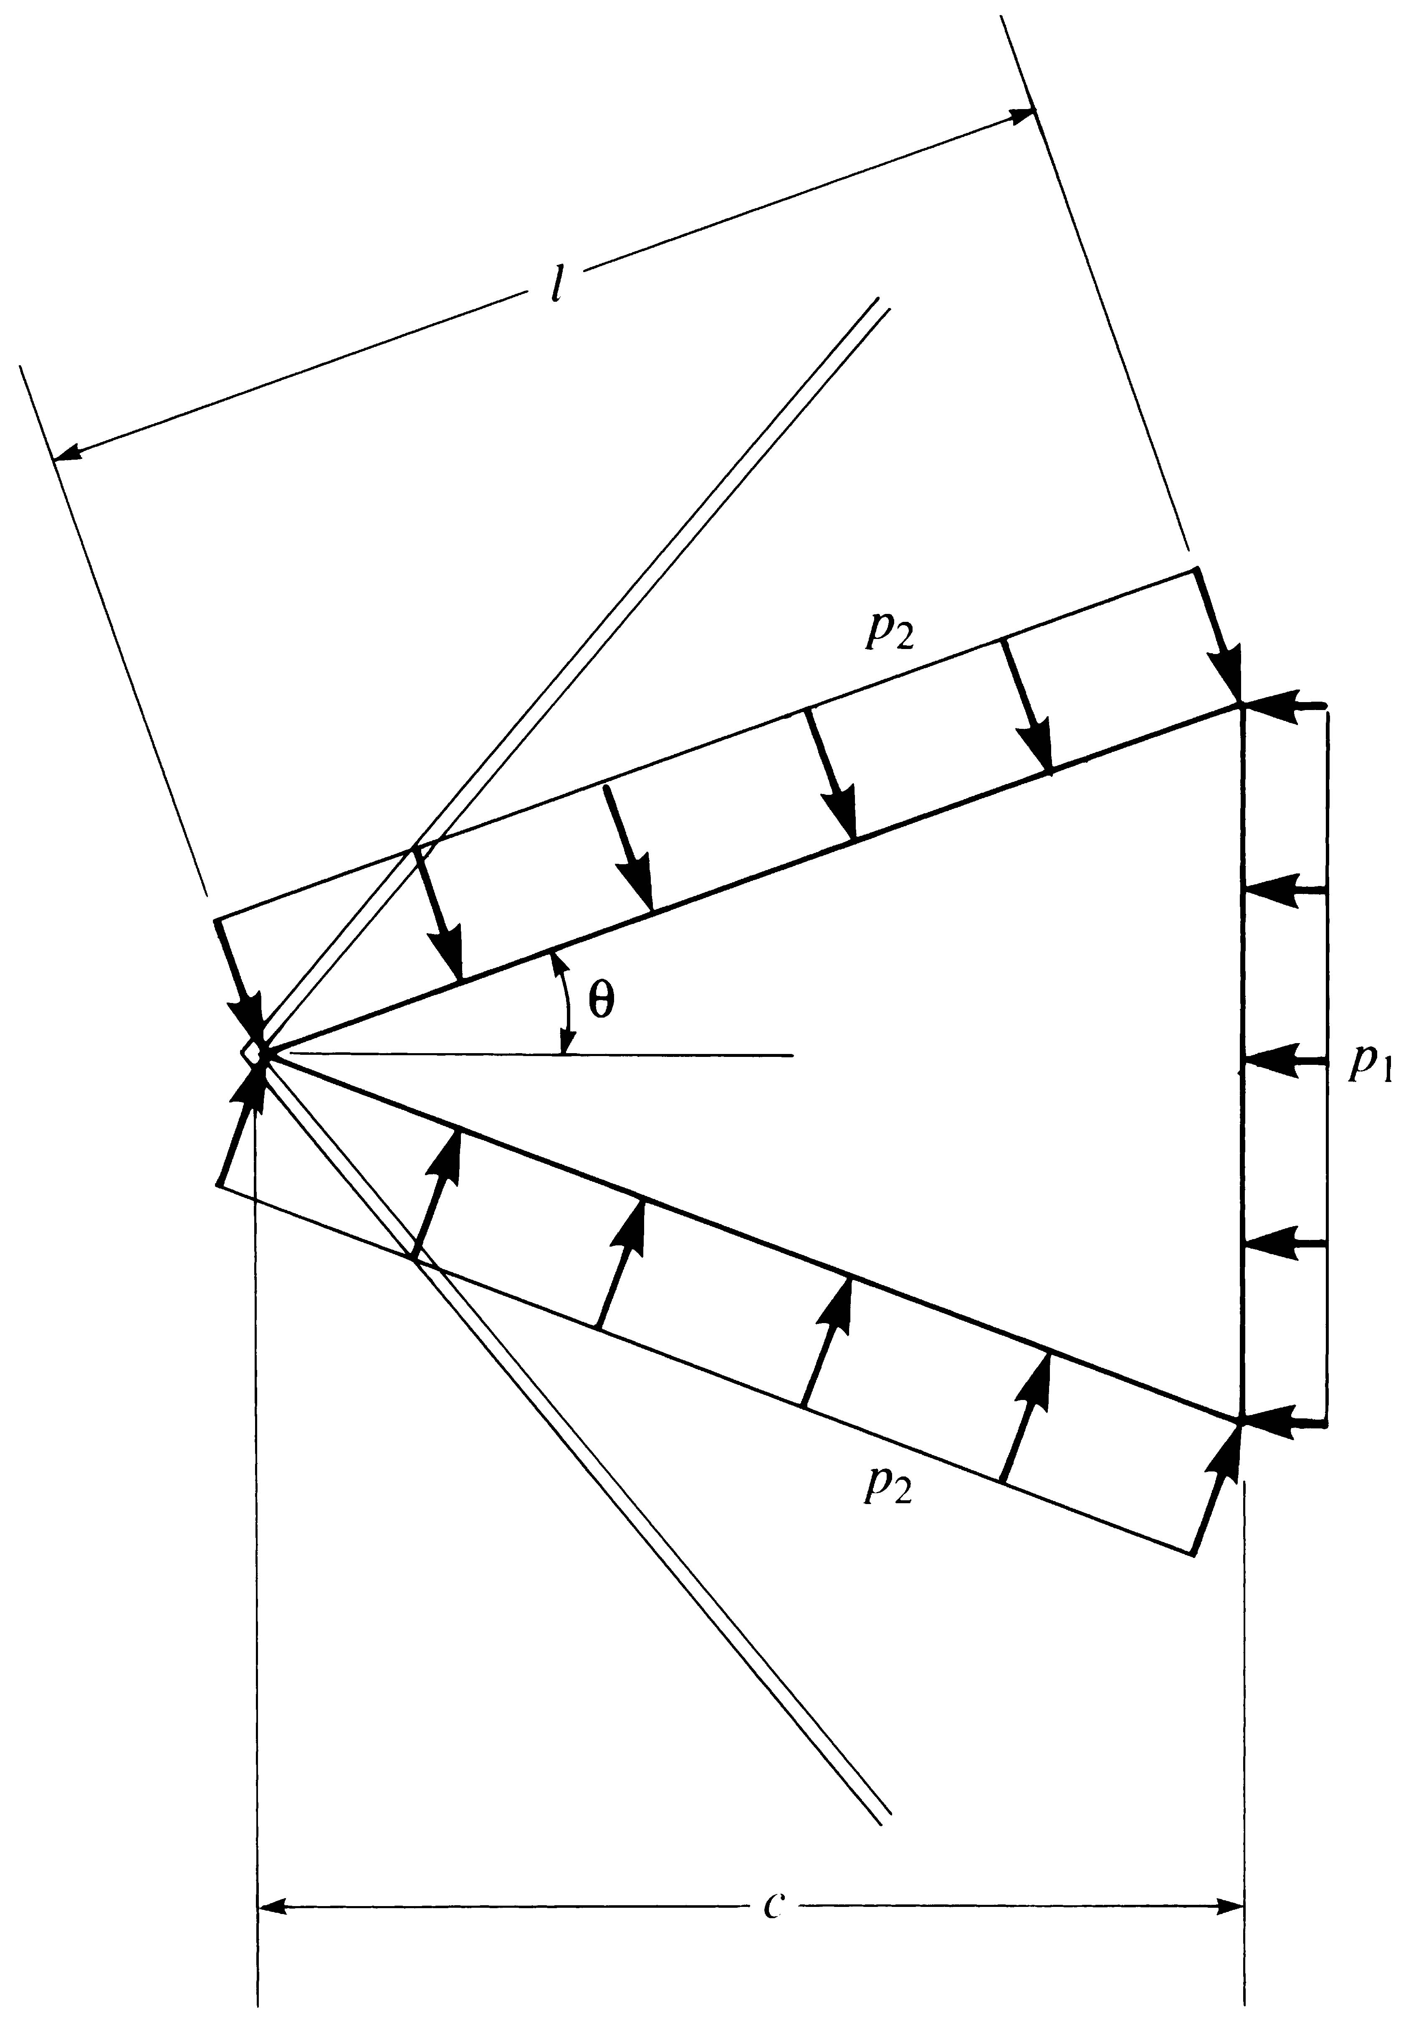
δ
p∞
Shear line

- Determine the angle that the oblique shock makes with the horizontal.
- Determine the pressure ratio p₂/p∞
- Calculate he drag coefficient, c_{d}=, where D is the drag force.

The flow at the trailing edge expands along a shear line as shown in the figure.

- Calculate the deflection angle, δ, of this shear layer.

